# JS Advanced: Regular Exam - 26.10.19

Exam problems for the ["JavaScript Advanced" course @ SoftUni](https://softuni.bg/courses/js-advanced). Submit your solutions in the SoftUni Judge system at <https://judge.softuni.bg/Contests/Compete/Index/1850#0> .

# Problem 1. Ski Inventory (DOM Manipulation)

### Use the given skeleton to solve this problem.

### Note: You have NO permission to change directly the given HTML *(index.html file)*.

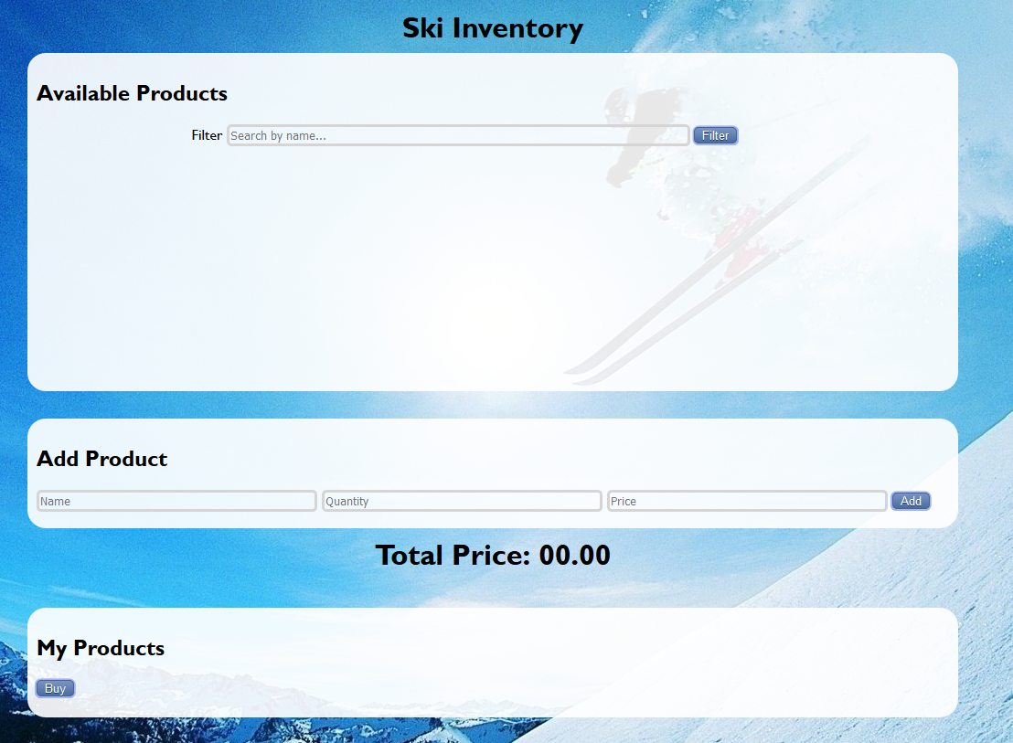

### Your Task

Write the missing JavaScript code to make the Ski Inventory application work as expected.

You should be able to **add** new products to the inventory.

Each product have **name**, **quantity** and **price**. When you click the **[Add]** button, a new **list item** should be added to the **Available Products**.

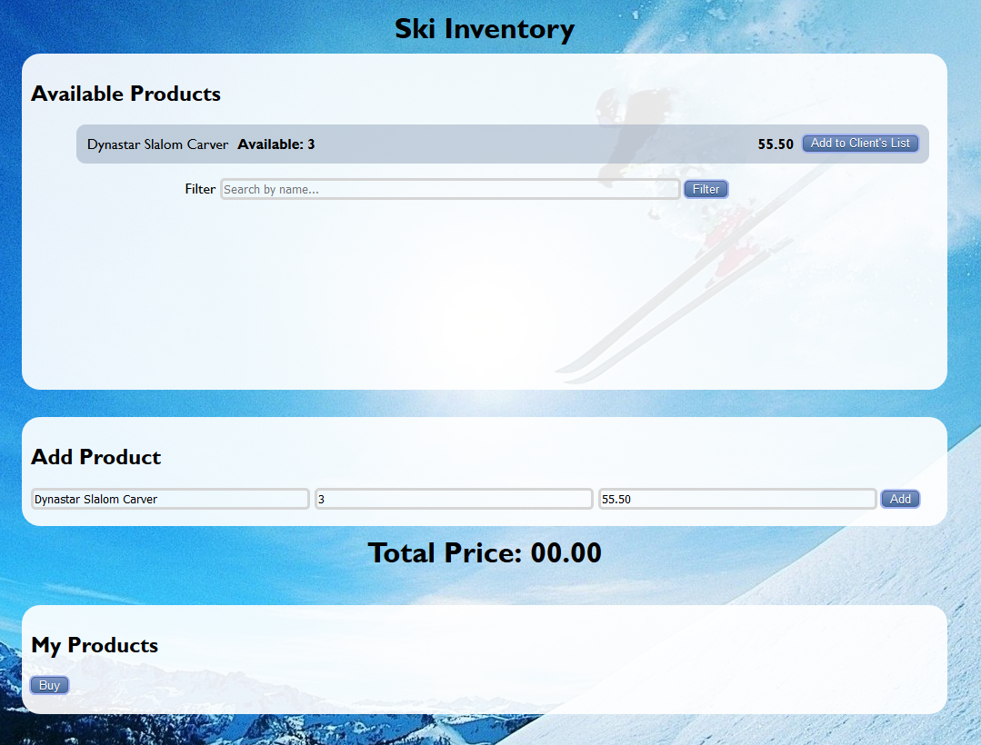

The new item should have the **following structure**:

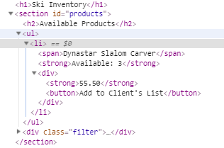

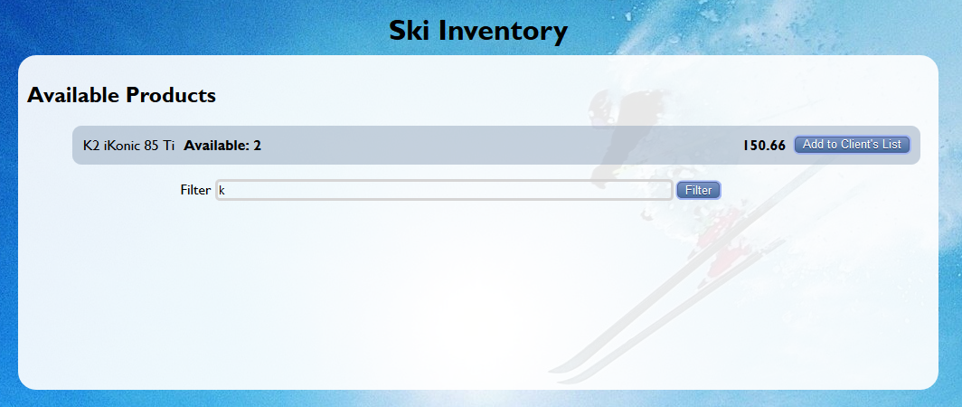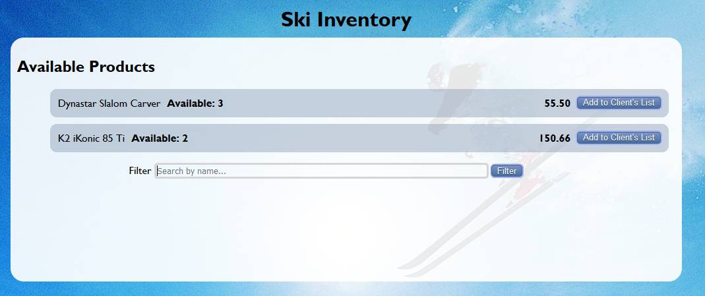

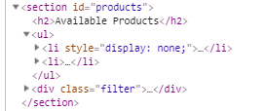Your App should have a **filter** functionality. This means that every time you press **the filter button** you should filter the items (**case insensitive**). Show those items that contain the string from the **filter input field** and hide all that do not match.

When you click the **[Add to Client's List]** button you should **add** that item to My Products section **ul** in the following format:

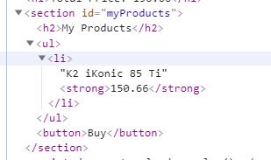

Every time you add new item to My Products you should **increase** the **Total Price** with the price of the item and **decrease** **available** products with **1**. If there are **no more** available products, you should **remove** this item from the **Available Products** **ul**.

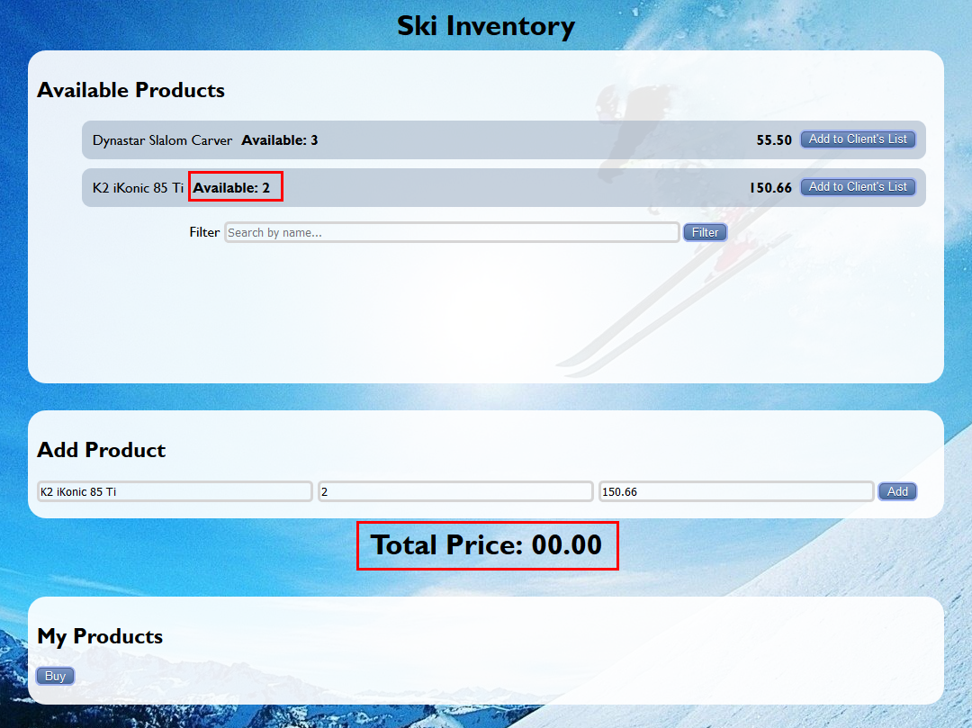

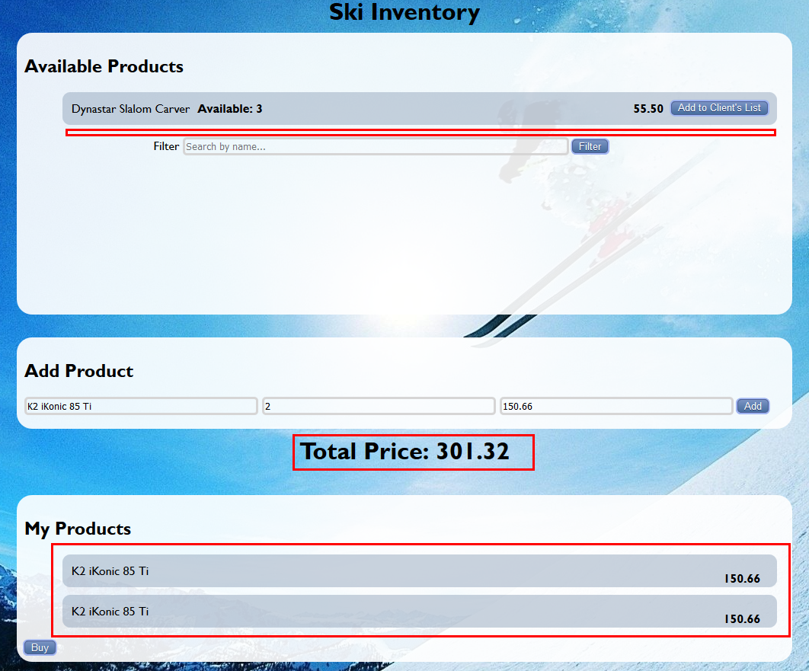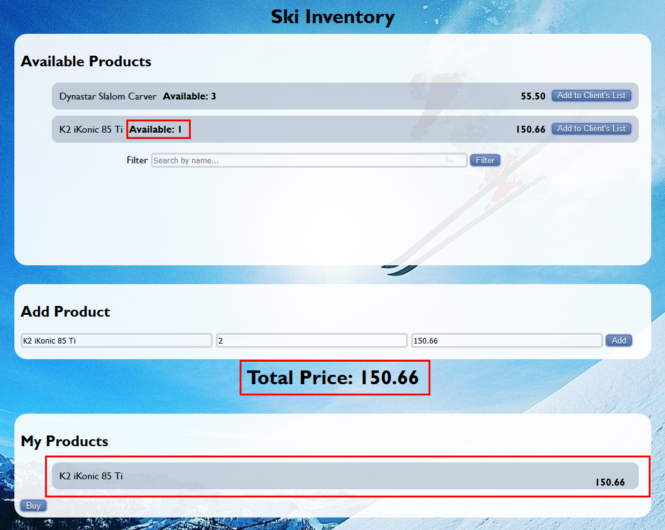

And last when you click the **[Buy]** button, you should **empty the ul** in My Products section and set the **Total Price to 0.00**.

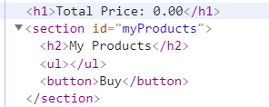

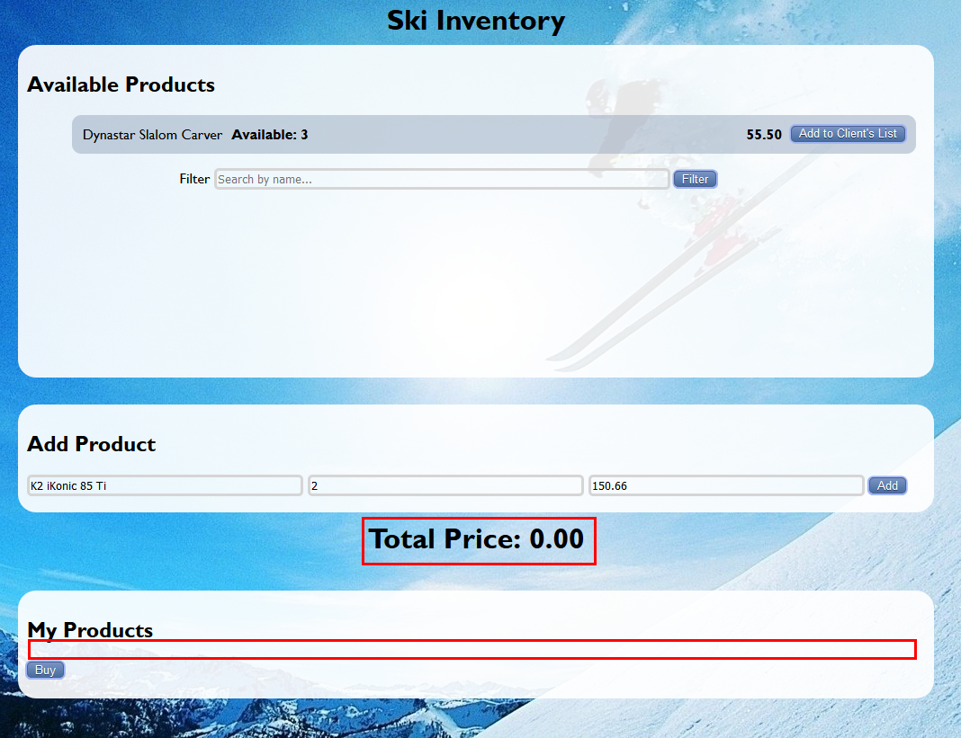

*GOOD LUCK!😊*